**#1 Create a program that takes a year as input and checks if it is a leap year or not**

n=int(input())

if n%4==0 or n%100==0 and n%400==0:

print("Leap year")

else:

print("Not a leap year")

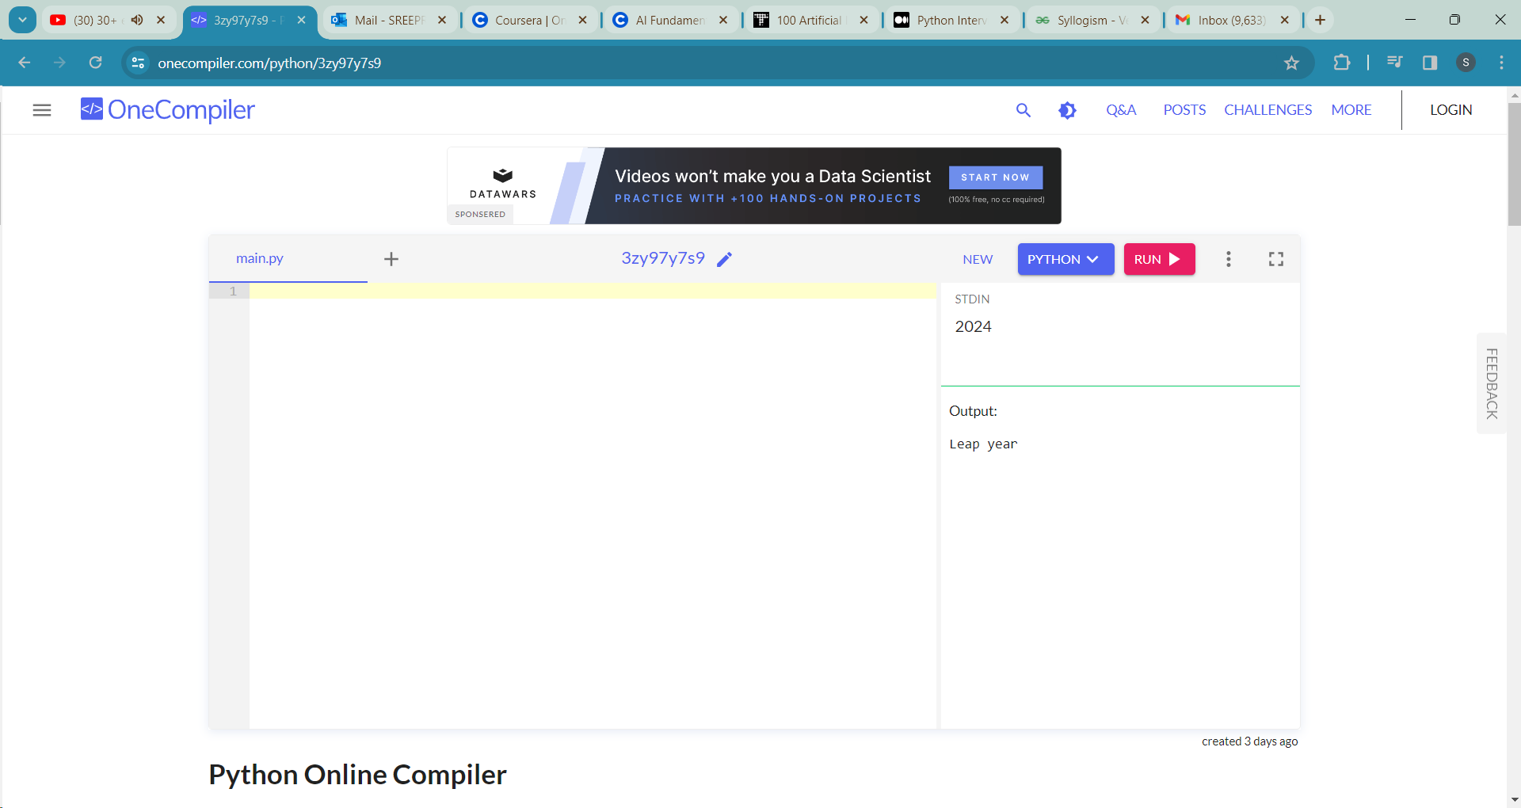

**#2.Given a list of integers, find all the even numbers and store them in a new list**

l1= input()

l=list(map(int,l1.split()))

for num in l:

if num%2==0:

print(num, end=" ")

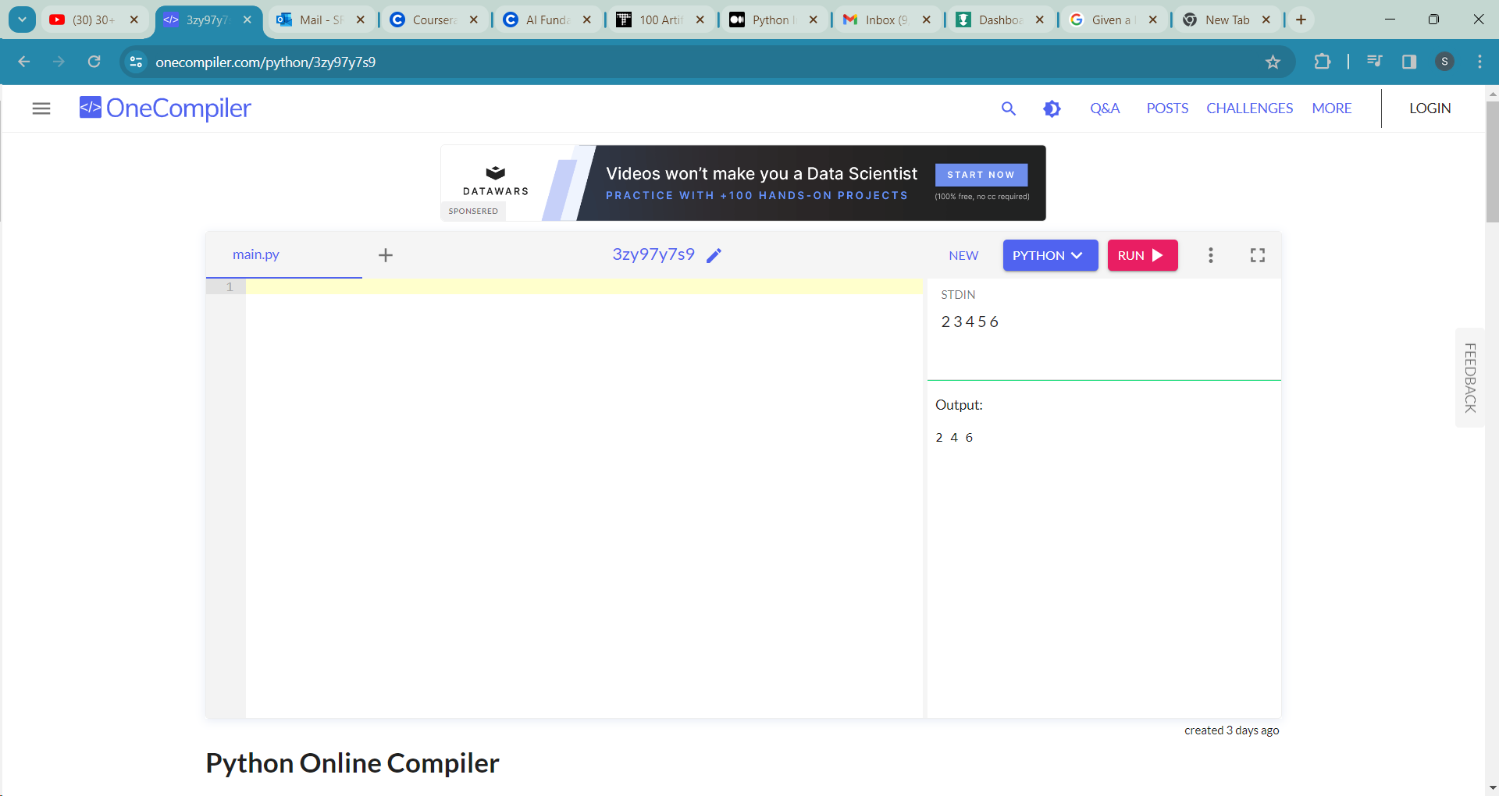

**# 3 Write a Python program to check if a given number is a prime number**

n=int(input())

flag=0

if n==1:

print("Not a prime")

for i in range(2,n):

if n%i==0:

flag=1

if flag:

print("Prime number")

else:

print("Not a prime number")

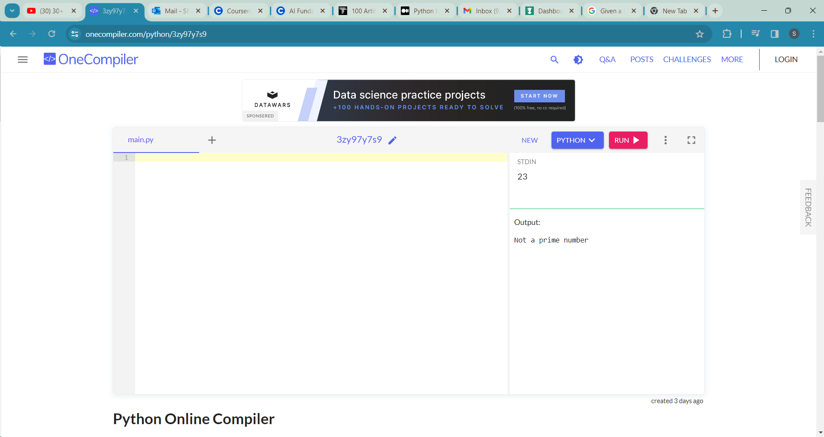

**#4, Create a program that generates the Fibonacci sequence up to a given number of terms**

n=int(input())

def Fibonacci(n):

if n<0:

print("Incorrect input")

elif n==0:

return 0

elif n==1 or n==2:

return 1

else:

return Fibonacci(n-1) +Fibonacci(n-2)

print(Fibonacci(n))

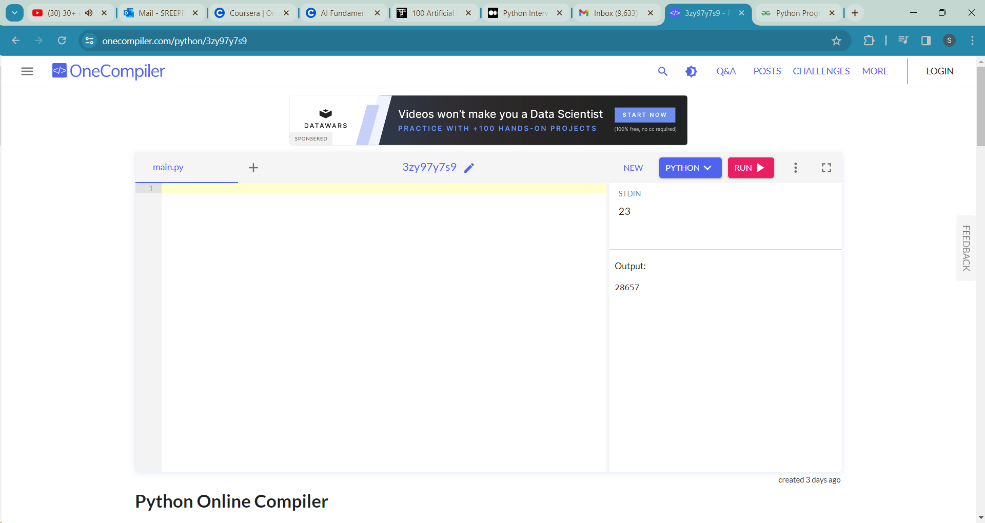

**#5 Given a list of names, print all names starting with the letter 'A'**

l=input()

l1=list(map(str, l.split()))

for i in l1:

if i[0]=='A':

print(i, end=" ")

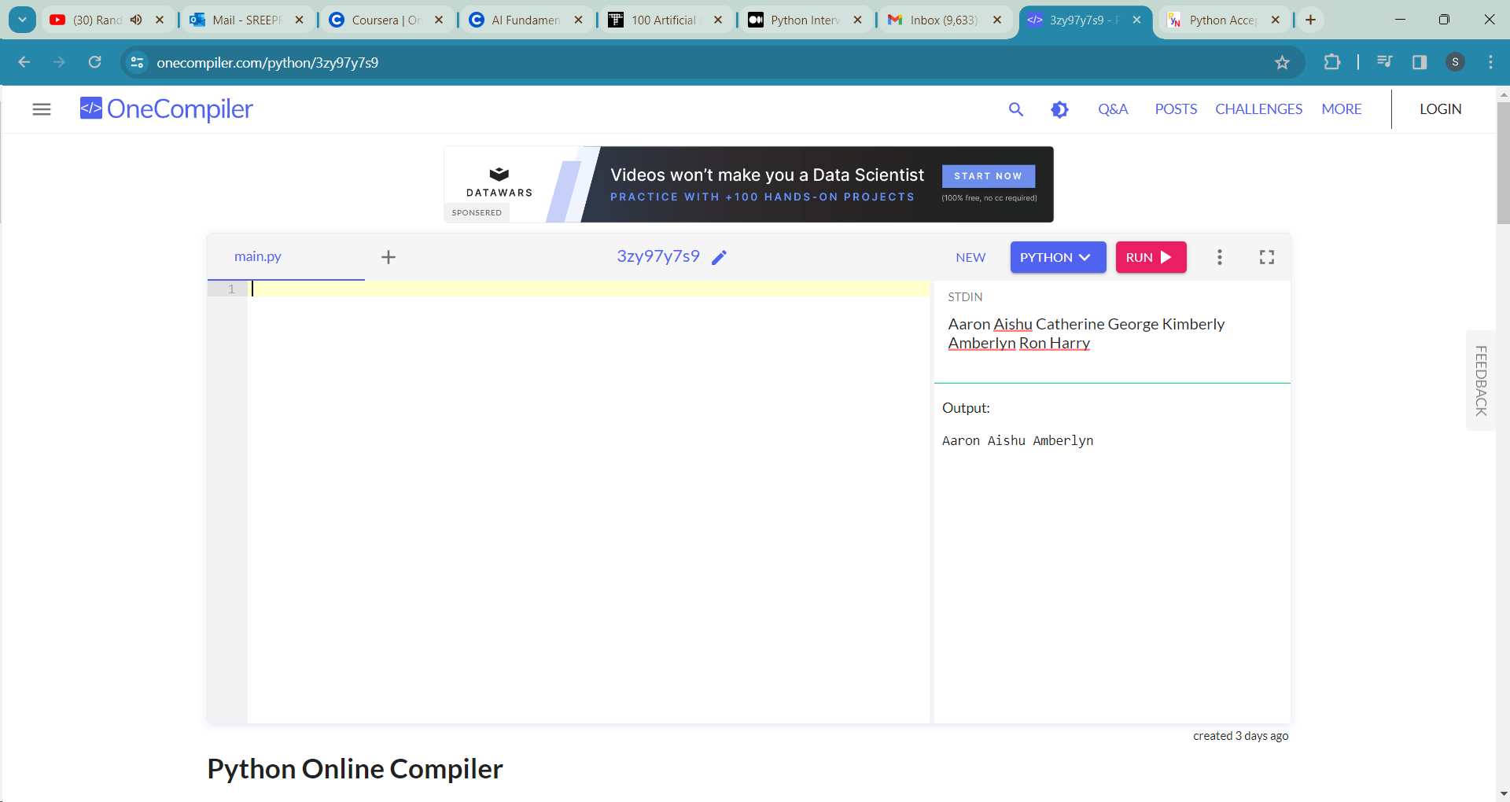

**#6 Implement a program that prints the multiplication table of a given number**

n=int(input())

m=int(input())

for i in range(1,m):

print(n,"x",i,"=",i*n)

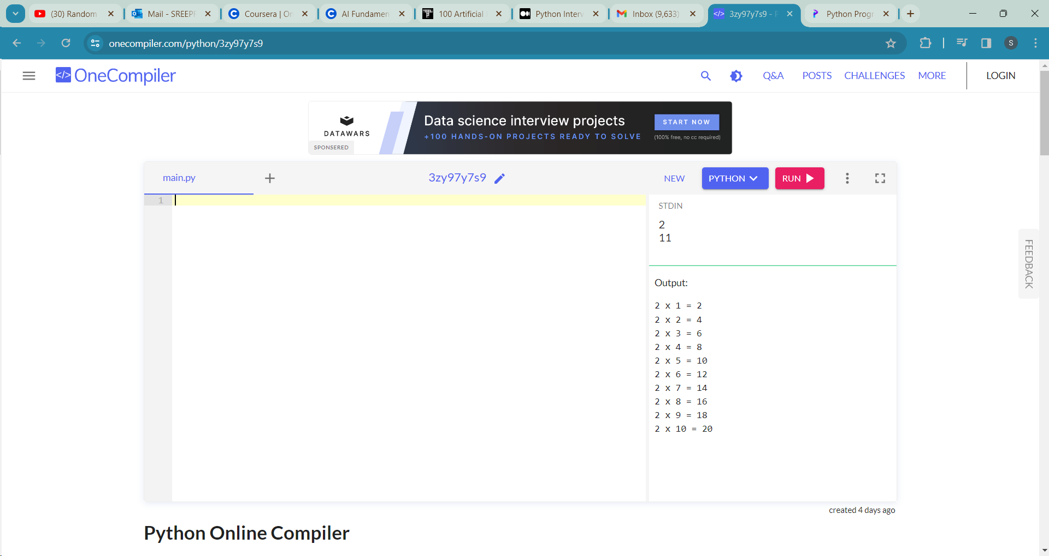

**#7 Write a program that calculates the factorial of a given number**

n=int(input())

factorial=1

for i in range(1,n+1):

factorial=factorial*i

print("The factorial of ",n," is ",factorial)

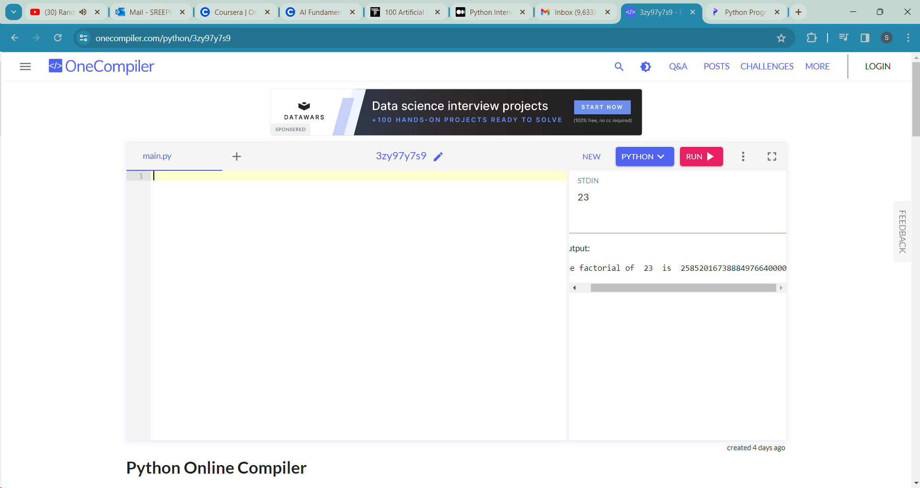

**#8 Create a loop that prints all prime numbers between 1 and 50**

l=int(input())

u=int(input())

for i in range(l,u+1):

if i>1:

for a in range(2,i):

if i%a==0:

break

else:

print(i)

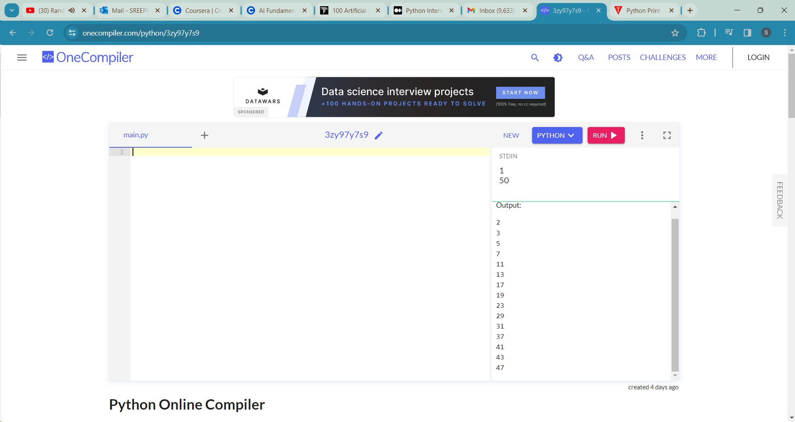

**#9 Given a list of words, count the number of words with more than five characters**

n=input()

m=list(map(str, n.split()))

b=0

a=len(m)

for i in range(a):

if (len(m[i])>5):

b+=1

print(b, end=" ")

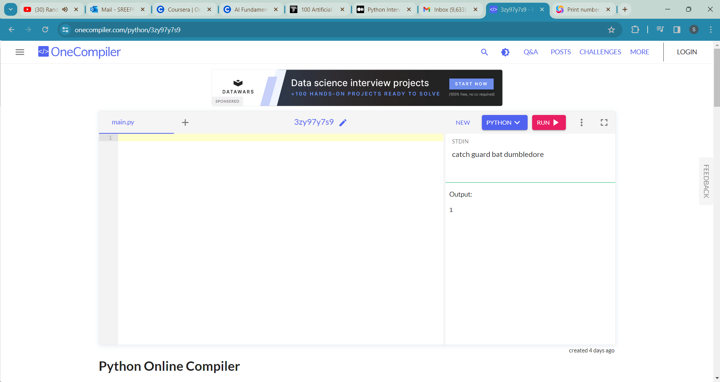

**#10.Calculate the sum of digits of a given number**

def getSum(n):

sum = 0

while (n != 0):

sum = sum + (n % 10)

n = n//10

return sum

n =int(input())

print(getSum(n))

